PART 1: RE – Regular Expression

Lexeme Classes: Define the classes to be used in your regular expression:

L = [A-Za-z] (Letters)
D = [0-9] (Digits)
P =. (Period)
U = _ (Underscore)
C = / (Comment)
NL = \n (Newline)
Q = “(Quote)
OP = ( (Open Parenthesis)
O = [^LDPUCNLQOP]

Define the RE to be used for: variables, literals and keywords:

* Comments: CC[^NL]*NL

* Variables: L[L|D|U]*

* Methods: L[L|D|U]*OP

* Literals:
- Numbers
IL = D[D]* (Integer Literal)
FL = D[D]*P[D]* (Float Literal)
- Strings
SL = Q[^Q]*Q (String Literal)
* Keywords:
KEY = {if, else, return, while, fn, true, false, i64, char, f64, String, bool, NULL, let}

PART 2: TD – Transition Diagram

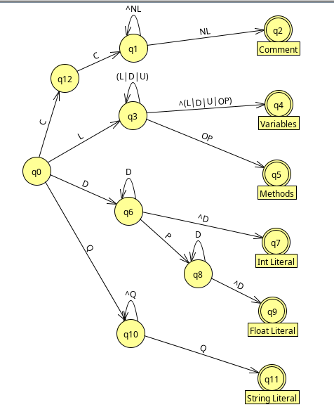

PART 3: TT – Transition Table

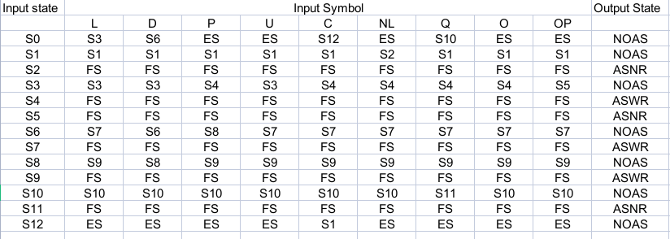

Update: May 30th 2023.

